1. Write a program to count the number of words in a file

Source code

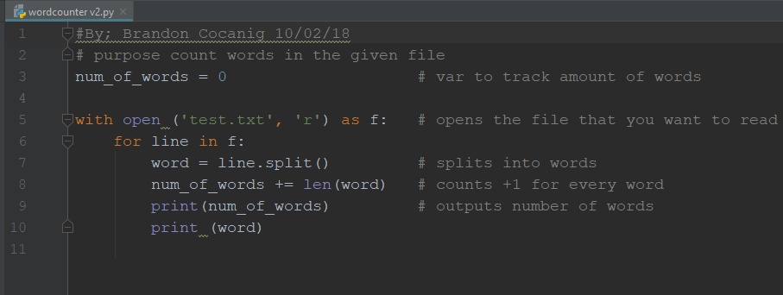

Output (the file had nine words)

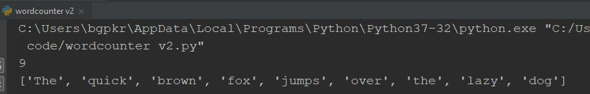

1. Write a program that generates 100 random integers and write them to a file
   1. Bonus point – sort the numbers in increasing order and then write them to a file

Source code

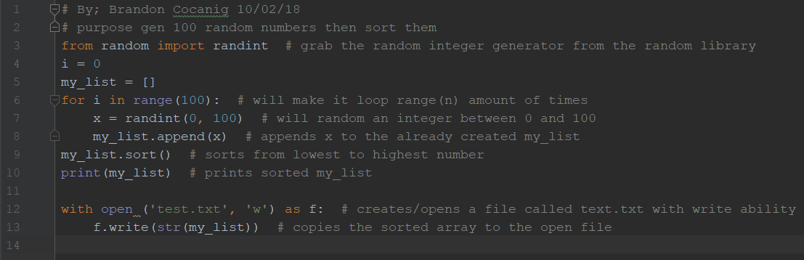

Output (there are 100 numbers all are sorted in order)



1. Write a program that counts the number of words in a file using a function

Source code

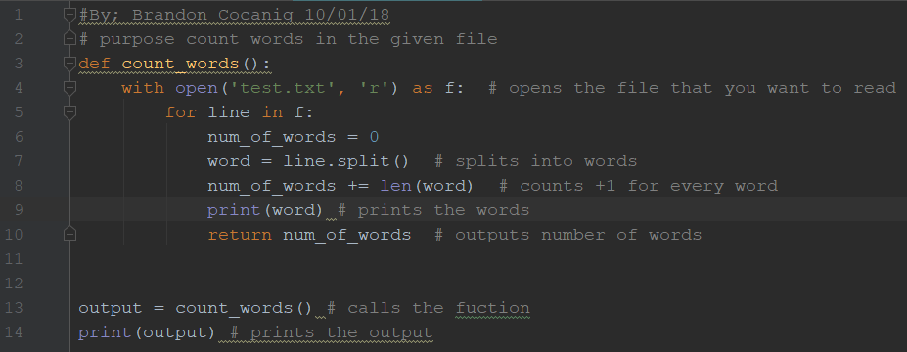

Output (the file had nine words)

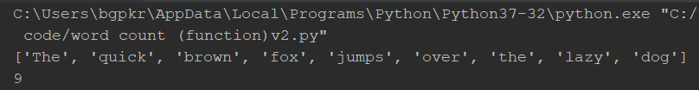

1. Write a program that converts temperature between F, C, K using functions

Source code

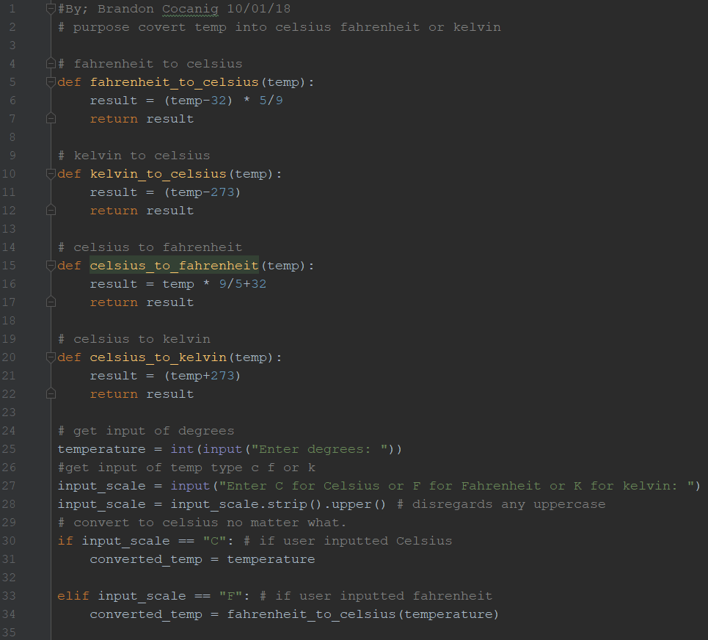

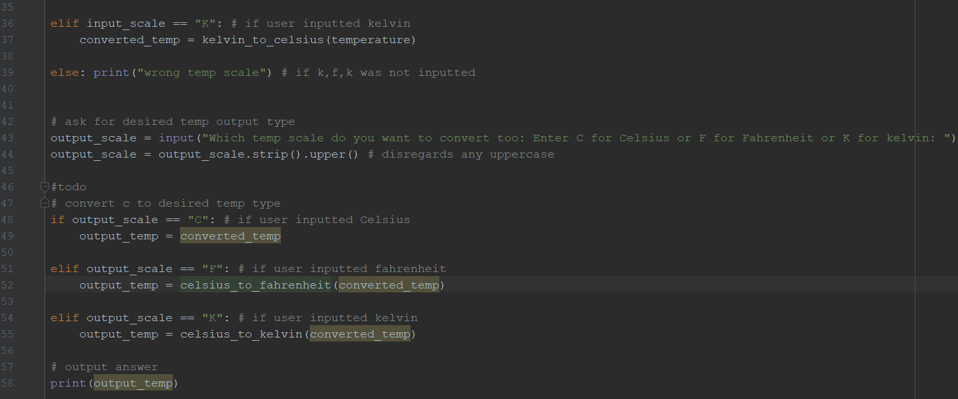

Output

